Supplementary information

Chromosome-level assembly and phylophenetic insights of Cladosporium oxysporum A3.I.1, a fungus with the ability to degrade polyurethane polymers

Authors
Ayixon Sánchez-Reyes¹, Itzayana Chavarría-Quintanilla², Martín Vargas-Suárez², Miguel Ángel Cevallos³, Itzel Gaytán⁴, Herminia Loza-Tavera²*
Affiliations
¹Investigador por México, SECIHTI-Instituto de Biotecnología, Universidad Nacional Autónoma de México, 62210 Cuernavaca, Morelos, México.
²Departamento de Bioquímica, Facultad de Química, Universidad Nacional Autónoma de México, 04510 Ciudad de México, México.
³Programa de Genómica Evolutiva, Centro de Ciencias Genómicas, Universidad Nacional Autónoma de México, 62210 Cuernavaca, Morelos, México.
⁴Departamento de Procesos y Tecnología, División de Ciencias Naturales e Ingeniería, Universidad Autónoma Metropolitana, Unidad Cuajimalpa, 05348 Ciudad de México, México.
*Author for Correspondence: Herminia Loza-Tavera, Departamento de Bioquímica, Universidad Nacional Autónoma de México, Ciudad de México, México, telephone number: +52 (55) 5622-5280; fax number: +52 (55) 5622-5329; hlozat@unam.mx.

Figure S1. K-mer spectrum and fitted models for Cladosporium oxysporum A3.I.1. K-mer plot was generated using Genomescope 2.0 with parameters set as default (K-mer length = 21, ploidy = 1n).

Table S1. GenomeScope 2.0 summary statistics for the analyzed genome.

Property | Min | Max
Homozygous (a) | 100% | 100%
Estimated Genome Haploid Length | 38,238,204 bp | 38,255,053 bp
Estimated Genome Repeat Length | 6,281,029 bp | 6,283,796 bp
Estimated Genome Unique Length | 31,957,175 bp | 31,971,257 bp
Model Fit | 83.39% | 96.49%
Read Error Rate | 0.26% | 0.26%

Table S2. KEGG Mapper reconstruction results complete modules for Cladosporium oxysporum A3.I.1.
- Pathway (434)
- Brite (50)
- Brite Table (6)
- Module (84)
Carbohydrate metabolism
Central carbohydrate metabolism
    - M00001 Glycolysis (Embden-Meyerhof pathway), glucose => pyruvate (11) (complete 9/9)
    - M00002 Glycolysis, core module involving three-carbon compounds (7) (complete 5/5)
    - M00003 Gluconeogenesis, oxaloacetate => fructose-6P (9) (complete 7/7)
    - M00307 Pyruvate oxidation, pyruvate => acetyl-CoA (4) (complete 1/1)
    - M00010 Citrate cycle, first carbon oxidation, oxaloacetate => 2-oxoglutarate (4) (complete 3/3)
    - M00004 Pentose phosphate pathway (Pentose phosphate cycle) (10) (complete 6/6)
    - M00006 Pentose phosphate pathway, oxidative phase, glucose 6P => ribulose 5P (4) (complete 2/2)
    - M00007 Pentose phosphate pathway, non-oxidative phase, fructose 6P => ribose 5P (5) (complete 4/4)
    - M00005 PRPP biosynthesis, ribose 5P => PRPP (1) (complete 1/1)
Other carbohydrate metabolism
    - M00081 Pectin degradation (3) (complete 3/3)
    - M00632 Galactose degradation, Leloir pathway, galactose => alpha-D-glucose-1P (4) (complete 4/4)
    - M00854 Glycogen biosynthesis, glucose-1P => glycogen/starch (5) (complete 2/2)
    - M00855 Glycogen degradation, glycogen => glucose-6P (3) (complete 3/3)
    - M00012 Glyoxylate cycle (5) (complete 5/5)
Energy metabolism
Sulfur metabolism
    - M00176 Assimilatory sulfate reduction, sulfate => H2S (5) (complete 3/3)
ATP synthesis
    - M00148 Succinate dehydrogenase (ubiquinone) (4) (complete 1/1)
Lipid metabolism
Fatty acid metabolism
    - M00082 Fatty acid biosynthesis, initiation (5) (complete 2/2)
    - M00083 Fatty acid biosynthesis, elongation (5) (complete 1/1)
    - M00415 Fatty acid elongation in endoplasmic reticulum (5) (complete 4/4)
    - M00086 beta-Oxidation, acyl-CoA synthesis (1) (complete 1/1)
    - M00861 beta-Oxidation, peroxisome, VLCFA (4) (complete 3/3)
Sterol biosynthesis
    - M00102 Ergocalciferol biosynthesis, FPP => ergosterol/ergocalciferol (13) (complete 13/13)
Lipid metabolism
    - M00089 Triacylglycerol biosynthesis (8) (complete 4/4)
    - M00098 Acylglycerol degradation (4) (complete 2/2)
    - M00091 Phosphatidylcholine (PC) biosynthesis, PE => PC (2) (complete 1/1)
    - M00092 Phosphatidylethanolamine (PE) biosynthesis, ethanolamine => PE (4) (complete 3/3)
    - M00093 Phosphatidylethanolamine (PE) biosynthesis, PA => PS => PE (3) (complete 3/3)
    - M00094 Ceramide biosynthesis (5) (complete 4/4)
    - M00099 Sphingosine biosynthesis (7) (complete 5/5)
    - M00100 Sphingosine degradation (2) (complete 2/2)
Nucleotide metabolism
Purine metabolism
    - M00049 Adenine ribonucleotide biosynthesis, IMP => ADP,ATP (5) (complete 4/4)
    - M00050 Guanine ribonucleotide biosynthesis, IMP => GDP,GTP (4) (complete 4/4)
    - M00053 Deoxyribonucleotide biosynthesis, ADP/GDP/CDP/UDP => dATP/dGTP/dCTP/dUTP (3) (complete 2/2)
    - M00958 Adenine ribonucleotide degradation, AMP => Urate (9) (complete 3/3)
    - M00959 Guanine ribonucleotide degradation, GMP => Urate (6) (complete 4/4)
Pyrimidine metabolism
    - M00051 De novo pyrimidine biosynthesis, glutamine (+ PRPP) => UMP (8) (complete 3/3)
    - M00052 Pyrimidine ribonucleotide biosynthesis, UMP => UDP/UTP,CDP/CTP (3) (complete 3/3)
    - M00938 Pyrimidine deoxyribonucleotide biosynthesis, UDP => dTTP (6) (complete 5/5)
Amino acid metabolism
Serine and threonine metabolism
    - M00020 Serine biosynthesis, glycerate-3P => serine (4) (complete 3/3)
    - M00018 Threonine biosynthesis, aspartate => homoserine => threonine (5) (complete 5/5)
    - M00621 Glycine cleavage system (3) (complete 3/3)
    - M00555 Betaine biosynthesis, choline => betaine (2) (complete 1/1)
Cysteine and methionine metabolism
    - M00338 Cysteine biosynthesis, homocysteine + serine => cysteine (2) (complete 2/2)
    - M00017 Methionine biosynthesis, aspartate => homoserine => methionine (7) (complete 7/7)
    - M00034 Methionine salvage pathway (9) (complete 8/8)
    - M00035 Methionine degradation (4) (complete 4/4)
Branched-chain amino acid metabolism
    - M00019 Valine/isoleucine biosynthesis, pyruvate => valine / 2-oxobutanoate => isoleucine (5) (complete 4/4)
    - M00570 Isoleucine biosynthesis, threonine => 2-oxobutanoate => isoleucine (7) (complete 5/5)
    - M00432 Leucine biosynthesis, 2-oxoisovalerate => 2-oxoisocaproate (3) (complete 3/3)
    - M00036 Leucine degradation, leucine => acetoacetate + acetyl-CoA (11) (complete 6/6)
Lysine metabolism
    - M00030 Lysine biosynthesis, AAA pathway, 2-oxoglutarate => 2-aminoadipate => lysine (8) (complete 8/8)
    - M00433 Lysine biosynthesis, 2-oxoglutarate => 2-oxoadipate (4) (complete 3/3)
Arginine and proline metabolism
    - M00028 Ornithine biosynthesis, glutamate => ornithine (5) (complete 4/4)
    - M00844 Arginine biosynthesis, ornithine => arginine (3) (complete 3/3)
    - M00015 Proline biosynthesis, glutamate => proline (3) (complete 2/2)
    - M00970 Proline degradation, proline => glutamate (2) (complete 1/1)
    - M00972 Proline metabolism (3) (complete 3/3)
Polyamine biosynthesis
    - M00133 Polyamine biosynthesis, arginine => agmatine => putrescine => spermidine (4) (complete 4/4)
    - M00134 Polyamine biosynthesis, arginine => ornithine => putrescine (2) (complete 2/2)
    - M00135 GABA biosynthesis, eukaryotes, putrescine => GABA (3) (complete 3/3)
Histidine metabolism
    - M00026 Histidine biosynthesis, PRPP => histidine (7) (complete 6/6)
Aromatic amino acid metabolism
    - M00022 Shikimate pathway, phosphoenolpyruvate + erythrose-4P => chorismate (6) (complete 4/4)
    - M00024 Phenylalanine biosynthesis, chorismate => phenylpyruvate => phenylalanine (3) (complete 2/2)
    - M00025 Tyrosine biosynthesis, chorismate => HPP => tyrosine (3) (complete 2/2)
Other amino acid metabolism
    - M00027 GABA (gamma-Aminobutyrate) shunt (4) (complete 3/3)
    - M00118 Glutathione biosynthesis, glutamate => glutathione (3) (complete 2/2)
Glycan metabolism
Nucleotide sugar biosynthesis
    - M00892 UDP-GlcNAc biosynthesis, eukaryotes, Fru-6P => UDP-GlcNAc (4) (complete 4/4)
    - M00549 UDP-Glc biosynthesis, Glc => UDP-Glc (3) (complete 3/3)
    - M00554 UDP-Gal biosynthesis, Gal => UDP-Gal (2) (complete 2/2)
    - M01000 GDP-Man biosynthesis, Fru-6P => GDP-Man (3) (complete 3/3)
Glycan biosynthesis
    - M00055 N-glycan precursor biosynthesis (13) (complete 13/13)
    - M00072 N-glycosylation by oligosaccharyltransferase (5) (complete 1/1)
    - M00073 N-glycan precursor trimming (4) (complete 4/4)
Metabolism of cofactors and vitamins
Cofactor and vitamin metabolism
    - M00916 Pyridoxal-P biosynthesis, R5P + glyceraldehyde-3P + glutamine => pyridoxal-P (2) (complete 1/1)
    - M00912 NAD biosynthesis, tryptophan => quinolinate => NAD (8) (complete 8/8)
    - M00120 Coenzyme A biosynthesis, pantothenate => CoA (5) (complete 3/3)
    - M00123 Biotin biosynthesis, pimeloyl-ACP/CoA => biotin (4) (complete 3/3)
    - M00881 Lipoic acid biosynthesis, plants and bacteria, octanoyl-ACP => dihydrolipoyl-E2/H (2) (complete 2/2)
    - M00880 Molybdenum cofactor biosynthesis, GTP => molybdenum cofactor (4) (complete 3/3)
    - M00141 C1-unit interconversion, eukaryotes (2) (complete 2/2)
    - M00868 Heme biosynthesis, animals and fungi, glycine => heme (8) (complete 8/8)
    - M00128 Ubiquinone biosynthesis, eukaryotes, 4-hydroxybenzoate + polyprenyl-PP => ubiquinone (6) (complete 8/8)
Biosynthesis of terpenoids and polyketides
Terpenoid backbone biosynthesis
    - M00095 C5 isoprenoid biosynthesis, mevalonate pathway (7) (complete 7/7)
    - M00367 C10-C20 isoprenoid biosynthesis, non-plant eukaryotes (3) (complete 3/3)

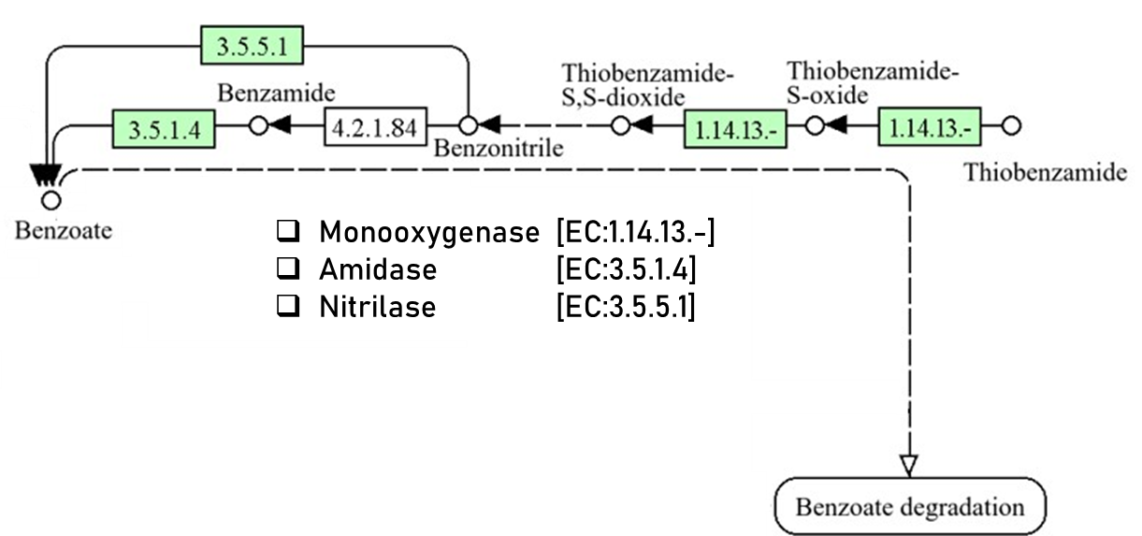

Figure S2. A complete pathway for the biodegradation of thiobenzamide to benzoate in the aminobenzoate degradation route was detected encoded in the Cladosporium oxysporum A3.I.1 genome, suggesting the potential for the utilization of PU degradation products as carbon sources by conversion into activated benzoate intermediates. Numbers in boxes correspond to E.C. numbers. Green and white boxes indicate enzymes encoded and not encoded in the A3.I.1 genome.

